**Program 1: Design an application to implement Button property in an android.**

**XML CODE:**

<?xml version="1.0" encoding="utf-8"?>  
<RelativeLayout xmlns:android="http://schemas.android.com/apk/res/android"  
 xmlns:app="http://schemas.android.com/apk/res-auto"  
 xmlns:tools="http://schemas.android.com/tools"  
 android:layout_width="match_parent"  
 android:layout_height="match_parent"  
 tools:context=".MainActivity">  
  
 <EditText  
 android:id="@+id/editText1"  
 android:layout_width="wrap_content"  
 android:layout_height="wrap_content"  
 android:layout_alignParentTop="true"  
 android:layout_centerHorizontal="true"  
 android:layout_marginTop="61dp"  
 android:ems="10"  
 android:inputType="number"  
 tools:layout_editor_absoluteX="84dp"  
 tools:layout_editor_absoluteY="53dp" />  
  
 <EditText  
 android:id="@+id/editText2"  
 android:layout_width="wrap_content"  
 android:layout_height="wrap_content"  
 android:layout_below="@+id/editText1"  
 android:layout_centerHorizontal="true"  
 android:layout_marginTop="32dp"  
 android:ems="10"  
 android:inputType="number"  
 tools:layout_editor_absoluteX="84dp"  
 tools:layout_editor_absoluteY="127dp" />  
  
 <Button  
 android:id="@+id/button"  
 android:layout_width="wrap_content"  
 android:layout_height="wrap_content"  
 android:layout_below="@+id/editText2"  
 android:layout_centerHorizontal="true"  
 android:layout_marginTop="109dp"  
 android:text="ADD"

Android:onClick:”click”  
 tools:layout_editor_absoluteX="148dp"  
 tools:layout_editor_absoluteY="266dp" />  
  
  
</RelativeLayout>

## Code for MainActivity.java:

package com.example.program1;  
  
import androidx.appcompat.app.AppCompatActivity;  
  
import android.os.Bundle;  
import android.view.View;  
import android.widget.Button;  
import android.widget.EditText;  
import android.widget.Toast;  
  
public class MainActivity extends AppCompatActivity

{  
 private EditText edittext1, edittext2;  
 private Button buttonSum;  
  
 @Override  
 protected void onCreate(Bundle savedInstanceState)

{  
 super.onCreate(savedInstanceState);  
 setContentView(R.layout.activity_main);  
 edittext1 = (EditText) findViewById(R.id.editText1);  
 edittext2 = (EditText) findViewById(R.id.editText2);  
 buttonSum = (Button) findViewById(R.id.button);  
  
 }  
 public void click(View view)

{

String value1=edittext1.getText().toString();  
 String value2=edittext2.getText().toString();  
 int a=Integer.parseInt(value1);  
 int b=Integer.parseInt(value2);  
 int sum=a+b;  
 Toast.makeText(getApplicationContext(),String.valueOf(sum), Toast.LENGTH_LONG).show();  
}

}

**OUTPUT:**

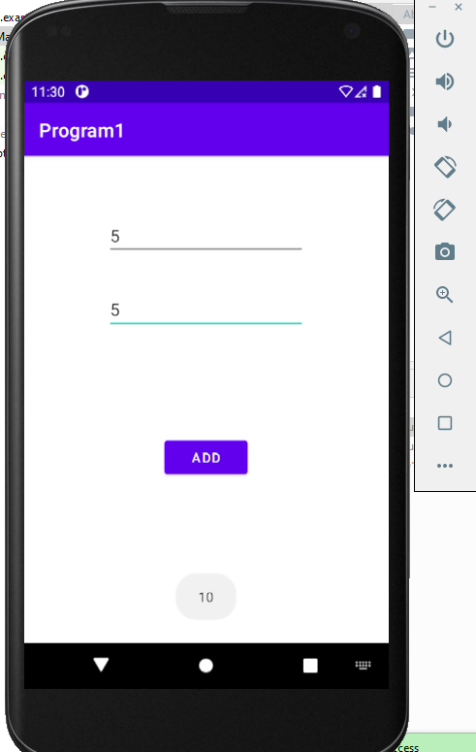

**Program 2: Design an application that contains phone contact in vertical linear manner. Selected contact appears at the top of the list.**

XML CODE:

<?xml version="1.0" encoding="utf-8"?>  
<RelativeLayout xmlns:android="http://schemas.android.com/apk/res/android"  
 xmlns:app="http://schemas.android.com/apk/res-auto"  
 xmlns:tools="http://schemas.android.com/tools"  
 android:layout_width="match_parent"  
 android:layout_height="match_parent"  
 tools:context=".MainActivity">  
  
 <Button android:id="@+id/button_call"  
 android:layout_width="match_parent"  
 android:layout_height="wrap_content"  
 android:onClick="onclickphonecall"  
 android:text="XYZ”  
 tools:layout_editor_absoluteX="131dp"  
 tools:layout_editor_absoluteY="59dp" />

</RelativeLayout>

## Code for MainActivity.java:

package com.example.program2;  
  
import androidx.appcompat.app.AppCompatActivity;  
  
import android.content.Intent;  
import android.net.Uri;  
import android.os.Bundle;  
import android.view.View;  
  
public class MainActivity extends AppCompatActivity {  
private Edittext t1;  
 @Override  
 protected void onCreate(Bundle savedInstanceState) {  
 super.onCreate(savedInstanceState);  
 setContentView(R.layout.activity_main);  
  
 }  
  
 public void onclickphonecall(View v)  
 {  
 String URL = t1.getText().toString();  
 Uri u = Uri.parse("tel:" + URL);  
 Intent i = new Intent(Intent.ACTION_VIEW, u);  
 startActivity(i);  
  
 }  
}

OUTPUT:

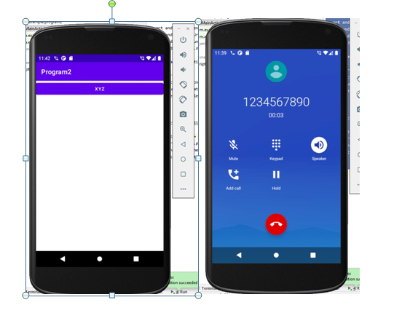

**Program 3: Design an application to implement Toggle Button property in an android.**

**XML CODE:**

<?xml version="1.0" encoding="utf-8"?>  
<androidx.constraintlayout.widget.ConstraintLayout xmlns:android="http://schemas.android.com/apk/res/android"  
 xmlns:app="http://schemas.android.com/apk/res-auto"  
 xmlns:tools="http://schemas.android.com/tools"  
 android:layout_width="match_parent"  
 android:layout_height="match_parent"  
 tools:context=".MainActivity">  
  
 <ToggleButton  
 android:id="@+id/toggleButton"  
 android:layout_width="wrap_content"  
 android:layout_height="wrap_content"  
 android:layout_marginLeft="8dp"  
 android:layout_marginTop="80dp"  
 android:text="ToggleButton"  
 android:textOff="Off"  
 android:textOn="On"  
 app:layout_constraintEnd_toStartOf="@+id/toggleButton2"  
 app:layout_constraintStart_toStartOf="parent"  
 app:layout_constraintTop_toTopOf="parent" />  
  
 <ToggleButton  
 android:id="@+id/toggleButton2"  
 android:layout_width="wrap_content"  
 android:layout_height="wrap_content"  
 android:layout_marginRight="60dp"  
 android:layout_marginTop="80dp"  
 android:text="ToggleButton"  
 android:textOff="Off"  
 android:textOn="On"  
 app:layout_constraintEnd_toEndOf="parent"  
 app:layout_constraintTop_toTopOf="parent" />  
  
 <Button  
 android:id="@+id/button"  
 android:layout_width="wrap_content"  
 android:layout_height="wrap_content"  
 android:layout_marginBottom="144dp"  
 android:layout_marginLeft="148dp"  
 android:text="Submit"

Android:onClick:”click”  
 app:layout_constraintBottom_toBottomOf="parent"  
 app:layout_constraintStart_toStartOf="parent" />  
  
  
</androidx.constraintlayout.widget.ConstraintLayout>

## Code for MainActivity.java:

package com.example.program3;  
  
import androidx.appcompat.app.AppCompatActivity;  
  
import android.os.Bundle;  
import android.view.View;  
import android.widget.Button;  
import android.widget.Toast;  
import android.widget.ToggleButton;  
  
public class MainActivity extends AppCompatActivity {  
 private ToggleButton toggleButton1, toggleButton2;  
 private Button buttonSubmit;  
  
 @Override  
 protected void onCreate(Bundle savedInstanceState) {  
 super.onCreate(savedInstanceState);  
 setContentView(R.layout.activity_main);

toggleButton1=(ToggleButton)findViewById(R.id.toggleButton);  
 toggleButton2=(ToggleButton)findViewById(R.id.toggleButton2);  
 buttonSubmit=(Button)findViewById(R.id.button);  
  
  
 }  
 public void Click(View view)

{  
 StringBuilder result = new StringBuilder();  
 result.append("ToggleButton1 : ").append(toggleButton1.getText());  
 result.append("\nToggleButton2 : ").append(toggleButton2.getText());  
 //Displaying the message in toast   
 Toast.makeText(getApplicationContext(), result.toString(),Toast.LENGTH_LONG).show();  
 }  
  
 }

OUTPUT:

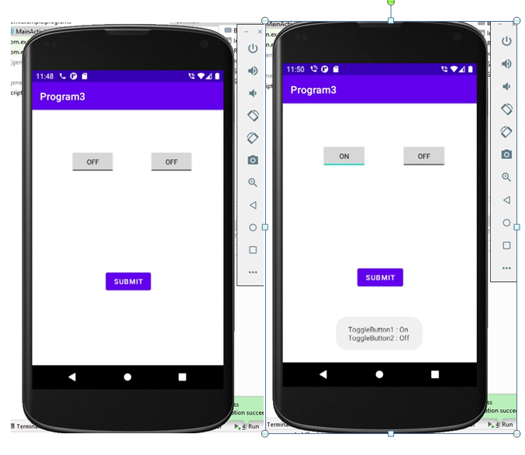

**Pgm4Checkbox**

*<?*xml version="1.0" encoding="utf-8"*?>*<androidx.constraintlayout.widget.ConstraintLayout xmlns:android="http://schemas.android.com/apk/res/android"  
 xmlns:app="http://schemas.android.com/apk/res-auto"  
 xmlns:tools="http://schemas.android.com/tools"  
 android:layout_width="match_parent"  
 android:layout_height="match_parent"  
 tools:context=".MainActivity">  
  
 <CheckBox  
 android:id="@+id/cb1"  
 android:layout_width="wrap_content"  
 android:layout_height="wrap_content"  
 android:text="Pizza"  
 app:layout_constraintBottom_toBottomOf="parent"  
 app:layout_constraintEnd_toEndOf="parent"  
 app:layout_constraintHorizontal_bias="0.545"  
 app:layout_constraintStart_toStartOf="parent"  
 app:layout_constraintTop_toTopOf="parent"  
 app:layout_constraintVertical_bias="0.163" />  
  
 <CheckBox  
 android:id="@+id/cb2"  
 android:layout_width="wrap_content"  
 android:layout_height="wrap_content"  
 android:text="Coffee"  
 app:layout_constraintBottom_toBottomOf="parent"  
 app:layout_constraintEnd_toEndOf="parent"  
 app:layout_constraintHorizontal_bias="0.545"  
 app:layout_constraintStart_toStartOf="parent"  
 app:layout_constraintTop_toTopOf="parent"  
 app:layout_constraintVertical_bias="0.326" />  
  
 <CheckBox  
 android:id="@+id/cb3"  
 android:layout_width="wrap_content"  
 android:layout_height="wrap_content"  
 android:text="Burger"  
 app:layout_constraintBottom_toBottomOf="parent"  
 app:layout_constraintEnd_toEndOf="parent"  
 app:layout_constraintHorizontal_bias="0.545"  
 app:layout_constraintStart_toStartOf="parent"  
 app:layout_constraintTop_toTopOf="parent"  
 app:layout_constraintVertical_bias="0.483" />  
  
 <Button  
 android:id="@+id/button"  
 android:layout_width="wrap_content"  
 android:layout_height="wrap_content"  
 android:text="submit"  
 app:layout_constraintBottom_toBottomOf="parent"  
 app:layout_constraintEnd_toEndOf="parent"  
 app:layout_constraintHorizontal_bias="0.545"  
 app:layout_constraintStart_toStartOf="parent"  
 app:layout_constraintTop_toTopOf="parent"  
 app:layout_constraintVertical_bias="0.78" />  
</androidx.constraintlayout.widget.ConstraintLayout>

package com.example.pgm4checkbox;  
  
import androidx.appcompat.app.AppCompatActivity;  
  
import android.os.Bundle;  
import android.view.View;  
import android.widget.Button;  
import android.widget.CheckBox;  
import android.widget.Toast;  
  
public class MainActivity extends AppCompatActivity  
{  
 CheckBox cb1,cb2,cb3;  
 Button button;  
  
  
 protected void onCreate(Bundle savedInstanceState)  
 {  
 super.onCreate(savedInstanceState);  
 setContentView(R.layout.*activity_main*);  
 cb1=(CheckBox)findViewById(R.id.*cb1*);  
 cb2=(CheckBox)findViewById(R.id.*cb2*);  
 cb3=(CheckBox)findViewById(R.id.*cb3*);  
 button=(Button)findViewById(R.id.*button*);  
 }  
  
 public void onClick(View view)  
 {  
 int totalamount=0;  
 StringBuilder result=new StringBuilder();  
 result.append("Selected Items:");  
 if(cb1.isChecked())  
 {  
 result.append("\nPizza 100Rs");  
 totalamount+=100;  
 }  
 if(cb2.isChecked())  
 {  
 result.append("\nCoffe 50Rs");  
 totalamount+=50;  
 }  
 if(cb3.isChecked())  
 {  
 result.append("\nBurger 120Rs");  
 totalamount+=120;  
 }  
 result.append("\nTotal: "+totalamount+"Rs");  
 *//Displaying the message on the toast* Toast.*makeText*(getApplicationContext(), result.toString(), Toast.*LENGTH_LONG*).show();  
 }  
  
 }

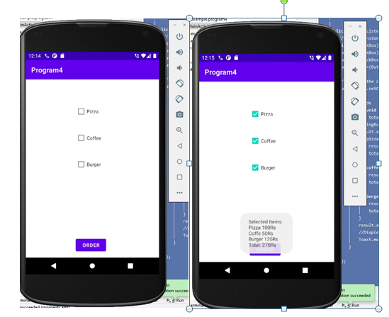

**Pgm5spinner**

*<?*xml version="1.0" encoding="utf-8"*?>*<androidx.constraintlayout.widget.ConstraintLayout xmlns:android="http://schemas.android.com/apk/res/android"  
 xmlns:app="http://schemas.android.com/apk/res-auto"  
 xmlns:tools="http://schemas.android.com/tools"  
 android:layout_width="match_parent"  
 android:layout_height="match_parent"  
 tools:context=".MainActivity">  
  
 <Spinner  
 android:id="@+id/spinner"  
 android:layout_width="269dp"  
 android:layout_height="8dp"  
 app:layout_constraintBottom_toBottomOf="parent"  
 app:layout_constraintEnd_toEndOf="parent"  
 app:layout_constraintHorizontal_bias="0.584"  
 app:layout_constraintStart_toStartOf="parent"  
 app:layout_constraintTop_toTopOf="parent"  
 app:layout_constraintVertical_bias="0.255" />  
</androidx.constraintlayout.widget.ConstraintLayout>

package com.example.pgm5spinner;  
  
import androidx.appcompat.app.AppCompatActivity;  
  
import android.os.Bundle;  
import android.widget.Adapter;  
import android.widget.AdapterView;  
import android.widget.ArrayAdapter;  
import android.widget.Spinner;  
import android.widget.Toast;  
import android.view.View;  
  
public class MainActivity extends AppCompatActivity implements AdapterView.OnItemSelectedListener  
{  
 String[] country={"India", "Argentina", "Italy", "Brazil", "Iraq"};  
  
  
 @Override  
 protected void onCreate(Bundle savedInstanceState) {  
 super.onCreate(savedInstanceState);  
 setContentView(R.layout.*activity_main*);  
 Spinner spin=(Spinner)findViewById(R.id.*spinner*);  
 spin.setOnItemSelectedListener(this);  
 ArrayAdapter aa = new ArrayAdapter(this,android.R.layout.*simple_spinner_item*,country);  
 aa.setDropDownViewResource(android.R.layout.*simple_spinner_dropdown_item*);  
 *//Setting the ArrayAdapter data on the Spinner* spin.setAdapter(aa);  
  
 }  
 public void onItemSelected(AdapterView<?> arg0, View arg1, int position, long id) {  
 Toast.*makeText*(getApplicationContext(),country[position] , Toast.*LENGTH_LONG*).show();  
 }  
 @Override  
 public void onNothingSelected(AdapterView<?> arg0) {  
 *// TODO Auto-generated method stub* }  
}

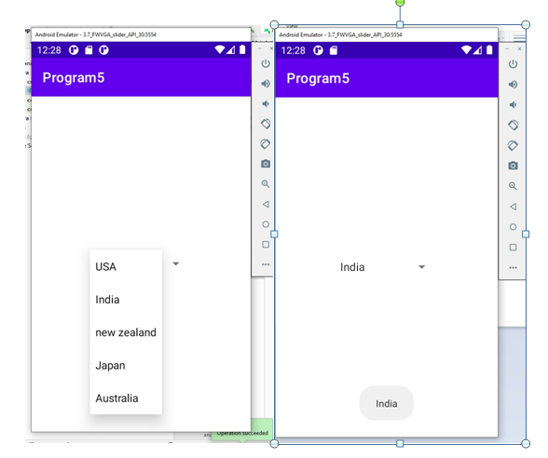

**pgm6ratingbar**

*<?*xml version="1.0" encoding="utf-8"*?>*<androidx.constraintlayout.widget.ConstraintLayout xmlns:android="http://schemas.android.com/apk/res/android"  
 xmlns:app="http://schemas.android.com/apk/res-auto"  
 xmlns:tools="http://schemas.android.com/tools"  
 android:layout_width="match_parent"  
 android:layout_height="match_parent"  
 tools:context=".MainActivity">  
  
 <RatingBar  
 android:id="@+id/ratingBar"  
 android:layout_width="wrap_content"  
 android:layout_height="wrap_content"  
 app:layout_constraintBottom_toBottomOf="parent"  
 app:layout_constraintEnd_toEndOf="parent"  
 app:layout_constraintHorizontal_bias="0.497"  
 app:layout_constraintStart_toStartOf="parent"  
 app:layout_constraintTop_toTopOf="parent"  
 app:layout_constraintVertical_bias="0.229" />  
  
 <Button  
 android:id="@+id/b1"  
 android:layout_width="wrap_content"  
 android:layout_height="wrap_content"  
 android:text="CLICK"  
 android:onClick="onClick"  
 app:layout_constraintBottom_toBottomOf="parent"  
 app:layout_constraintEnd_toEndOf="parent"  
 app:layout_constraintHorizontal_bias="0.47"  
 app:layout_constraintStart_toStartOf="parent"  
 app:layout_constraintTop_toTopOf="parent"  
 app:layout_constraintVertical_bias="0.551" />  
</androidx.constraintlayout.widget.ConstraintLayout>

package com.example.ratingbarpgm6;  
  
import androidx.appcompat.app.AppCompatActivity;  
  
import android.os.Bundle;  
import android.widget.RatingBar;  
import android.widget.Button;  
import android.widget.Toast;  
import android.view.View;  
  
  
  
public class MainActivity extends AppCompatActivity {  
 RatingBar ratingBar;  
 Button b1;  
  
 @Override  
 protected void onCreate(Bundle savedInstanceState) {  
 super.onCreate(savedInstanceState);  
 setContentView(R.layout.*activity_main*);  
 ratingBar=(RatingBar)findViewById(R.id.*ratingBar*);  
 b1=(Button)findViewById(R.id.*b1*);  
  
 }  
 public void onClick(View arg0)  
 {  
 String rating=String.*valueOf*(ratingBar.getRating());  
  
 Toast.*makeText*(getApplicationContext(),rating,Toast.*LENGTH_LONG*).show();  
 }  
}

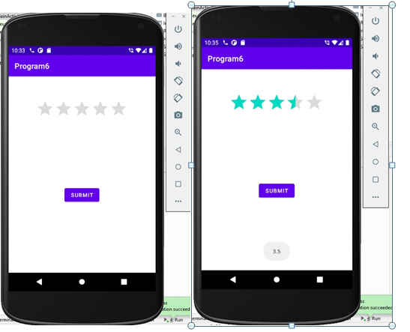

**pgm7seekbar**

*<?*xml version="1.0" encoding="utf-8"*?>*<androidx.constraintlayout.widget.ConstraintLayout xmlns:android="http://schemas.android.com/apk/res/android"  
 xmlns:app="http://schemas.android.com/apk/res-auto"  
 xmlns:tools="http://schemas.android.com/tools"  
 android:layout_width="match_parent"  
 android:layout_height="match_parent"  
 tools:context=".MainActivity">  
  
 <SeekBar  
 android:id="@+id/seekBar"  
 android:layout_width="match_parent"  
 android:layout_height="wrap_content"  
 android:layout_marginEnd="8dp"  
 android:layout_marginStart="8dp"  
 android:layout_marginTop="372dp"  
 app:layout_constraintEnd_toEndOf="parent"  
 app:layout_constraintStart_toStartOf="parent"  
 app:layout_constraintTop_toTopOf="parent" />  
  
</androidx.constraintlayout.widget.ConstraintLayout>

package com.example.pgm7_seekbar;  
import androidx.appcompat.app.AppCompatActivity;  
  
import android.os.Bundle;  
import android.widget.SeekBar;  
import android.widget.Toast;  
  
public class MainActivity extends AppCompatActivity {  
 SeekBar seekBar;  
 @Override  
 protected void onCreate(Bundle savedInstanceState)  
 {  
 super.onCreate(savedInstanceState);  
 setContentView(R.layout.*activity_main*);  
 seekBar=(SeekBar)findViewById(R.id.*seekBar*);  
 seekBar.setOnSeekBarChangeListener(new SeekBar.OnSeekBarChangeListener() {  
 @Override  
 public void onProgressChanged(SeekBar seekBar, int progress,  
 boolean fromUser) {  
 Toast.*makeText*(getApplicationContext(),"seekbar progress: "+progress, Toast.*LENGTH_SHORT*).show();  
 }  
  
 @Override  
 public void onStartTrackingTouch(SeekBar seekBar) {  
 Toast.*makeText*(getApplicationContext(),"seekbar touch started!", Toast.*LENGTH_SHORT*).show();  
 }  
  
 @Override  
 public void onStopTrackingTouch(SeekBar seekBar) {  
 Toast.*makeText*(getApplicationContext(),"seekbar touch stopped!",  
 Toast.*LENGTH_SHORT*).show();  
 }  
 });  
 }  
}

